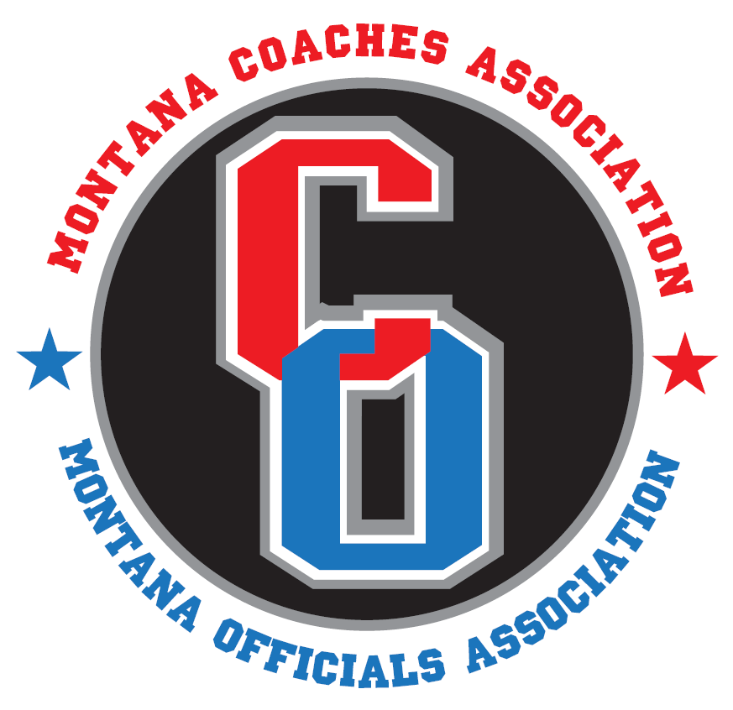
July 28, 2026

TO: MOA BASKETBALL OFFICIALS

FROM: SCOTT MCDONALD, ASSISTANT DIRECTOR

RE: MECHANICS TRAINING

The Regional Directors approved the following requirement for the 2008-09 school year for football and basketball: Attendance will be required for each registered official at a certified MOA mechanics clinic or verification of training by a “Train the Trainer” representative who has attended the MOA mechanics clinic at the MCA in Great Falls and who provides the training at a mandatory mechanics study club for all MOA basketball and football officials. Recertification of trainers will be required concurrently with the printing of each new NFHS officials manual. For the first year, football and basketball will be piloted and committees will be created to formulate mechanics clinics for soccer, softball, wrestling and volleyball.

Also please note the penalty if an official does not meet this requirement, which will be added to the 2008-09 MOA Handbook, Article XXIII:

C. Officials shall drop one rating classification for any of the following reasons:

- Failure to complete the mandatory rules clinic and/or mechanics clinic for their sport renders an official ineligible for any postseason contest. The official’s rating is restored when they complete the next rules and/or mechanics clinic for their sport. Officials must notify the MOA office for restoration.

Please note: If an official does not meet the new mechanics clinic requirement, he/she would be ineligible to officiate in the post season.

There are three ways that MOA officials will be able to meet the requirement for mechanics training:

- The MOA will host a “Train the Trainer” clinic each summer in conjunction with the Montana Coaches Association (MCA) Clinic in Great Falls. A representative from each pool must attend this “Train the Trainer” clinic. Each representative will be credited with mechanics clinic attendance and will then be provided with training and materials to facilitate training of other officials in their pool.

- Individuals who have received mechanics training at the Great Falls MOA / MCA Clinic will utilize two study clubs during the season to provide mechanics training to all officials in their pool. This will meet the mechanics clinic requirement, which will allow officials to be eligible for the post season.

- Attendance at other mechanics clinics / camps that have been approved by the MOA Office and MOA Regional Directors will satisfy the requirement. Here is a list of approved basketball clinics to date:
Basketball
Magic City Officiating Camp (Kelly Duneman)
May 23-25, Billings, MT

Miles City Basketball Officiating Camp (Jim Collins)
June 6-8, Miles City Community College
Miles City, MT

Dave Hall Basketball Officiating Camp
June 12-14, Utah State University, Logan, UT

MSU Bozeman Women’s Officiating Camp (Kelly Duneman)
June 13-15, MSU Bozeman

MSU Bozeman Men’s Officiating Camp (Kelly Duneman)
June 19-21, MSU Bozeman

Big Sky State Games Officiating Camp (Kelly Duneman)
July 18-20, Billings, MT

Please note that attending other mechanics clinics / camps will not be approved as a “Train the Trainer” clinic for providing local pool mechanics training. “Train the Trainer” clinics will only be held at the MOA / MCA Clinic in Great Falls.

Information about the MOA / MCA “Train the Trainer” clinic to be held in August of 2008 will be sent to each pool in the near future. If you have any questions or concern, please contact me.

